Please read this carefully before coming to class to participate in the Beer Game simulation.

Background
The Beer game is a classic simulation demonstrating typical supply chain behavior. It was developed by the Systems Dynamics Group at Massachusetts Institute of Technology’s Sloan School of Management in the 1960s. The simulation is simple, yet powerful in terms of the principles it demonstrates. Although called the “beer” game, it does not require any drinking (sorry,) and really has little to do with beer. Instead it’s all about how orders and inventory move through a series of members in a supply chain.

The supply chain for a simulated beer company includes a factory, where the beer is produced, a distributor, a wholesaler, and a retailer. The retailer meets the demands of end customers and orders stock from the wholesaler. The wholesaler supplies the retailer and orders stock from the distributor. The distributor obtains stock directly from the factory. The simulated chain is much simpler than a realistic supply chain in that there is only one retailer, one wholesaler, and one distributor for the one factory.

Retailer
Wholesaler
Distributor
Factory
The object of the simulation is to minimize costs for the supply chain. The class will be divided into groups of 4 or 8 people each, where each group is one supply chain, and thus one competitive team. There are only two kinds of costs. One is inventory carrying cost and the other is backlog cost. At the end of each simulated week, these two costs are assessed. For each item in inventory, a $.50 charged is assessed. For every item on backlog (stock has been demanded, but the member does not have inventory to meet the demand), a charge of $1 is assessed. These inventory charges are accrued continually throughout the duration of the simulation and displayed on the game screen. Note that unfulfilled demand is never lost, rather, the demand is backlogged and will eventually be satisfied when stock is available.

The flow of information and product along the supply chain is limited and involves time lags. When a member orders stock from its supplier at the end of a simulated week (orders are always placed at the end of the week), that order is not seen by the supplier until the beginning of the second week after the order is placed. Similarly, when stock is shipped from a supplier, it arrives two weeks later. The only allowed form of communication in the game, between two adjacent positions in the chain, is via orders and stock shipped. No other communication is allowed. There is also no direct communication between any position of the supply chain and any non-adjacent position. (For example, no announcing of present demand, present inventory, and so forth.)

Game play procedures
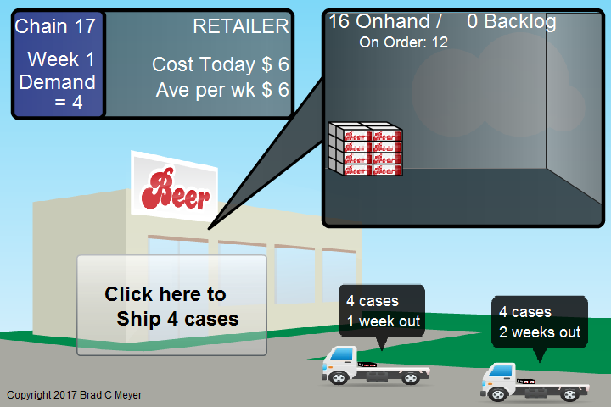

After entering your user name and chain information, you will see a screen similar to that above, which is for the retailer. The other positions have different background graphics. You see on the screen, upper left, game statistics for your position only, upper right, your current on hand inventory, lower right, inventory that has been shipped to you, but has not yet arrived, and lower left, an action button.

When each new week starts, you will see an animation of the week’s inventory being delivered and adding to the on-hand amount. The action button tells you how many will be shipped out to the customer that week. The amount shipped is automatically computed from demand and supply. You will ship out as much of the demand as possible (including any backlogged demand) given your inventory on hand. That shipment will occur when you click the button. Then you will be asked to place an order from your supplier. The action button will change to that shown below.

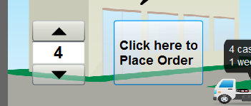
You adjust the amount upwards or downwards and then click to place your order. At that time, the picture will turn dark to simulate the weekend and once everyone in your chain has placed their order, the lights will come back on and you will proceed with the next week.
Game play proceeds for around 60 weeks, then you will see the summarized results for your chain.

